Create District Six + Langa combined tour package
A powerful, emotionally rich half‑day experience connecting Cape Town’s past, present, and community future.

Overview
This combined tour brings together District Six — the heart of forced removals — and Langa, Cape Town’s oldest Black township. Guests experience two deeply significant communities in one seamless narrative: displacement → resilience → cultural revival.

Tour Flow & Experience
1. District Six Museum & Surrounds

NO PICS YET!!!

Explore District Six

- The District Six Museum
- Stories of families forcibly removed
- The vibrant culture that once filled the streets
- The ongoing fight for land restitution
- This stop sets the emotional foundation for the rest of the tour.

2. Drive Through the Old District Six Area

NO PICS YET!!!

Guests experience:

- Empty land still awaiting restitution
- Churches and landmarks that survived demolition
- The contrast between past destruction and present rebuilding
- This creates a powerful visual connection to the museum’s stories.

3. Arrival in Langa Township
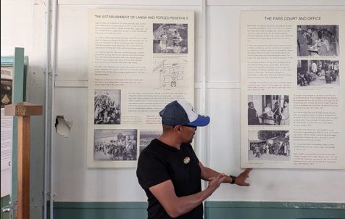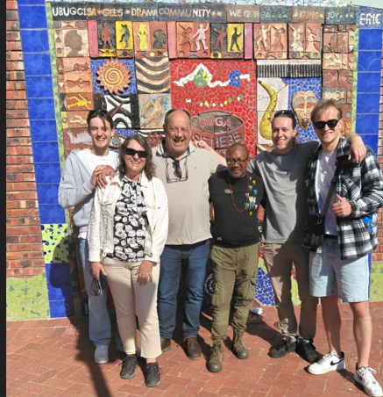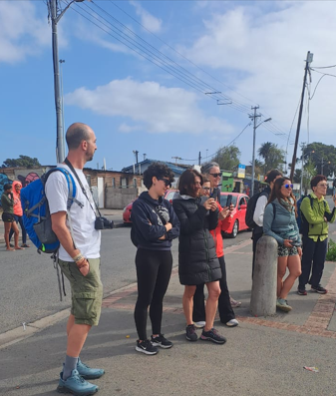
Your local accredited community guide welcomes you into Langa, sharing:

- The history of Langa as the first planned Black township
- Resistance movements and cultural identity
- Modern community upliftment projects
4. Guga S’thebe Arts & Culture Centre
Guests explore:
- Art studios
- Ceramic workshops
- Community craft markets
- Colourful murals and cultural expressions
- This is one of the most photographed locations in Langa.

5. Guided Cultural Walk Through Langa
Your guide leads you through:
- Traditional hostels and modern housing
- Local entrepreneurship
- Daily life in Langa
- Community upliftment initiatives
This is the most interactive part of the tour — authentic, safe, and meaningful.
Pricing-
2–3 Guests: R2,300 pp
4 Guests: R2,000 pp
5–7 Guests: R1,700 pp (15% discount)
Children 0-3yrs Free
Children 4-12yrs R1200
Teens Adult rate and depending on the group size
Number of People | Pricing Per Person | Children’s Pricing | What’s Included | What’s Not Included
2–3 Guests | R2,300 pp | - Children 0–3: Free - Children 4–12: R1,200 pp - Teens 13–17: Adult rate | - Hotel pick-up & drop-off - Driver-guide - District Six Museum entry - Langa community guide - Guga S’thebe visit - Langa cultural walk - Bottled water - All entry fees | - Meals - Personal purchases - Optional upgrades - Gratuities
4 Guests | R2,000 pp | - Children 0–3: Free - Children 4–12: R1,200 pp - Teens 13–17: Adult rate | Same inclusions as above | Same exclusions as above
5–7 Guests | R1,700 pp (15% discount) | - Children 0–3: Free - Children 4–12: R1,200 pp - Teens 13–17: Adult rate | Same inclusions as above | Same exclusions as above

